PRESCHOOL FEES
Non-refundable Annual Fees
Registration: (2/1-2/28) $85
(3/1-1/31/23) $100

Material Fee $275

2-Year-Olds – 4-Year-Olds (Pre-K)
(must be age of class entering by 9/30)

4 days a week
(Tuesday – Friday)
Tuition $250/month
($2,250 annually)

Before Care
$175/month* or $13/day
After Care
$450/month* or $33/day
After & Extended Care
(Not determined at this time)

For information on our elementary school grades (K-5th), please contact our office.

"Have I not commanded you? Be strong and courageous. Do not be afraid; do not be discouraged, for the Lord your God will be with
you wherever you go.”

Joshua 1:9

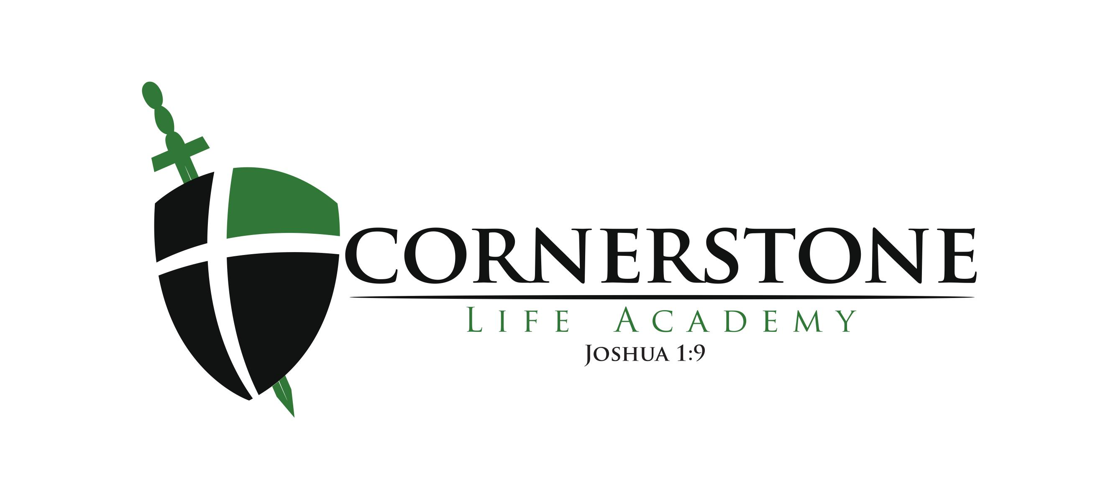

For more information and application please contact us:

Office: (540)374-1876

Email:
CLA@cssbchurch.org

Or visit our church website at
www.cssbchurch.org

2023-2024

Preschool (2-year-olds – 4-year-olds)
(Must be the age of the class by 9/30)
Tuesday – Friday 9:15 a.m. - 12:15 p.m.
Before Care 8:05 a.m.
After Care 12:15 p.m. - 3:00 p.m.

“Fix these words of mine in your hearts and minds; tie them as symbols on your hands and bind them on your foreheads. Teach them to your children, talking about them when you sit at home and when you walk along the road, when you lie down and when you get up…”
Deuteronomy 11:18-19

Cornerstone Life Academy
56 McWhirt Loop, Fredericksburg VA 22406
Phone number: (540)374-1876
Web site: www.cssbchurch.org
E-mail: CLA@cssbchurch.org

MISSION STATEMENT

Cornerstone Life Academy is a Christ-centered life program seeking to partner with parents in the training and education of their children. CLA offers a strong academic program and instills in students the knowledge of God, equipping them to follow Jesus Christ in life.

PRESCHOOL PROGRAM

Our program provides activities in a fun and flexible environment to help in the development of the child’s physical, emotional, mental, social and spiritual self. We seek to teach our preschoolers social readiness skills including personal management and daily routine. We also guide our children in the development of self-expression and problem solving. Most importantly, our staff helps the children feel God’s love by aiding in their spiritual growth through the teaching of God’s Word.
To ensure academic success with a strong biblical philosophy, the administration has prayerfully selected Abeka Book Publications as the core of our curriculum for our 2-year and 3-year-old classes. We will use BJU Press in our 4-year-old classes, with Abeka supplemented.

Preschool 2’s – Bright, eye catching books and materials are used for language development and listening skills to include color words, shapes, animals, transportation, health, safety, manners and science. Pre-math skills of counting to 25 and number concepts to 10 are taught through a variety of games and activities. Socialization is a key component of this age group. Self-help skills and potty training are a special focus.

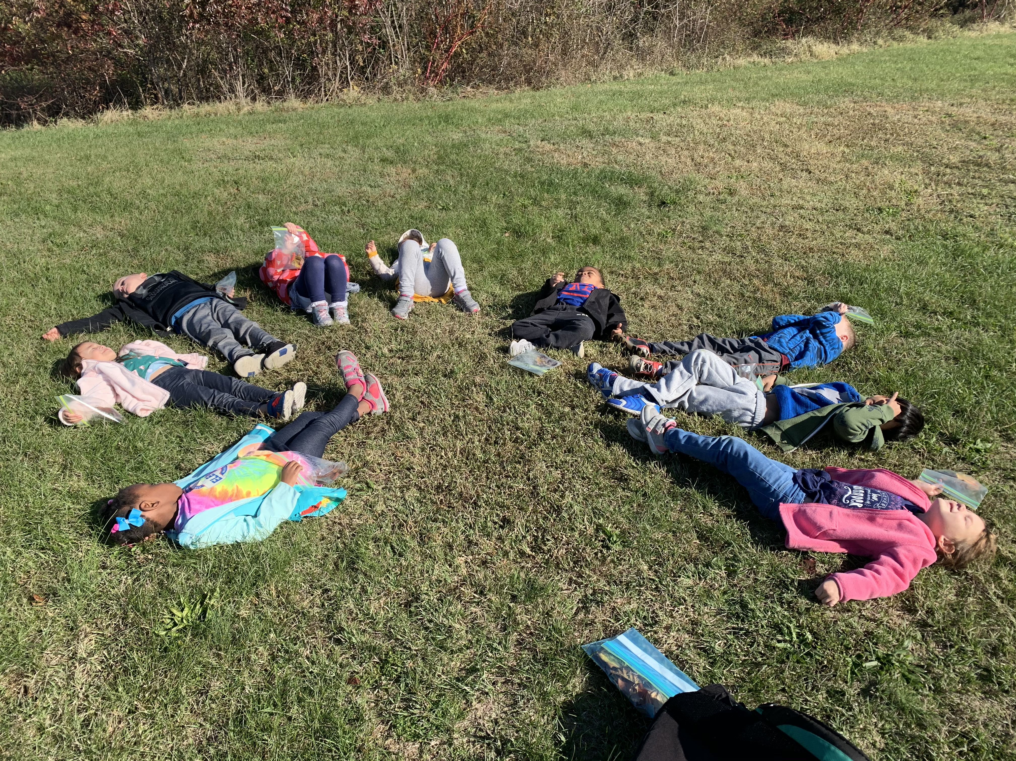

K-3’s – Children learn the name, sound and formation of short vowels and consonants. Math skills of counting to 30 and number concepts to 15 are taught through games and activities. Bible, scripture memory, singing, colors, shapes, following directions, listening skills, health, safety, manners, community helpers and science are an integral part of the curriculum.

K-4’s – Children focus on phonics, sounds, blends and words; beginning reading skills are taught. Poetry and finger play for enjoyment and memorization are incorporated. Writing: manuscript printing of letters and writing of first name. Numbers: recognition and counting to 100; concepts, before and after numbers, largest and smallest to 20. Our curriculum consists of Bible lessons, scripture memory, art, music, science, social living, and many other fun activities.
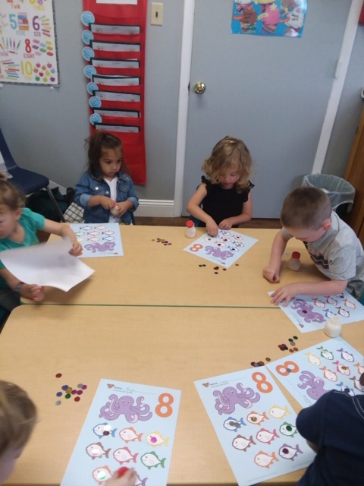

“Train up a child in the way he should go,
And when he is old, he will not depart from it.”

Proverbs 22:6

